Khanh Q.Bach-Smartphone supply chain simulation using ARENA SIMAN

Initially, data are mainly adopted from Zhao et al. (2022) article in which the expected outcome for a large mobile manufacturer with 13 assembly lines is 2600 units per day. However, to simplify the model, this outcome will be evaluated in the much smaller scale of 6000 units per month (30 days) with 1 assembly line (2600*30/13=6000). Besides, the total amount of working hour per day is 14 (Zhao et al., 2022). Additionally, this article will designate labour and machinery as the two primary resource types for the smartphone production process as well as two resources for the transportation process from distributors to retailers. As modified from Brown's (2022) article, the average wage for manufacturing costs will be $9 USD per hour, while the machine's operating costs are estimated to be $4 USD per hour. In addition, the cost of distributing goods by ship and plane will be 0.5 USD and 3 USD per kilogramme, respectively (Pallet2Ship, n.d.). In terms of time allocation, since there is a lack of data from related articles, this paper assumed that each of the suppliers will provide 20 raw materials per 2 hours. Similarly, because this paper adjusted the production scale of mobile phone supply chain as aforementioned, the processing time for every process module will be assumed as shown in ***figure 1***. To be clear, the delivery process’s times are also assumed as in ***figure 1*** because the transportation time of goods varies largely depend on several conditions such as distance, weather, traffic and so on (DFH global logistics, n.d.)

|  |  |  |  |  |  |  |  |
| --- | --- | --- | --- | --- | --- | --- | --- |
| Process name | Preparation | Assembling | Quality check | Rework | Order weighted | Ship delivery | Plane delivery |
| Delay type | Triangular | Triangular | Triangular | Constant | Constant | Triangular | Triangular |
| Unit | 2,3,5 (minutes) | 10,13,15  (minutes) | 10,13,15  (minutes) | 10  (minutes) | 5  (minutes) | 3,4,5 (hours) | 1,1.5,3  (hours) |

***Figure 1: Time allocation in process modules***

Secondly, in the designing stage, from discrete processing panel, this research applies 2 *create* modules for 2 suppliers, 5 r*outes* and 4 *stations* for the transportation of materials and products within the supply chain. Next, 4 *process* module are created in the manufacturing process including preparation, assembling, quality check and rework. Meanwhile, 1 *assign* module and 3 additional *process* modules are applied in distribution process to weight the order and transport the phones to the retailer. Additionally, 5 *decides* modules, 1 *batch* module and 7 *record* modules are integrated. Lastly, 5 *dispose* modules are used to represent 3 disposing points for defected goods and 2 retailers. The model’s design could be viewed in ***figure 2*.** Lastly, in alignment with the data adopted above, the model is executed 3 times for 30 days with 14 hours of work per day.

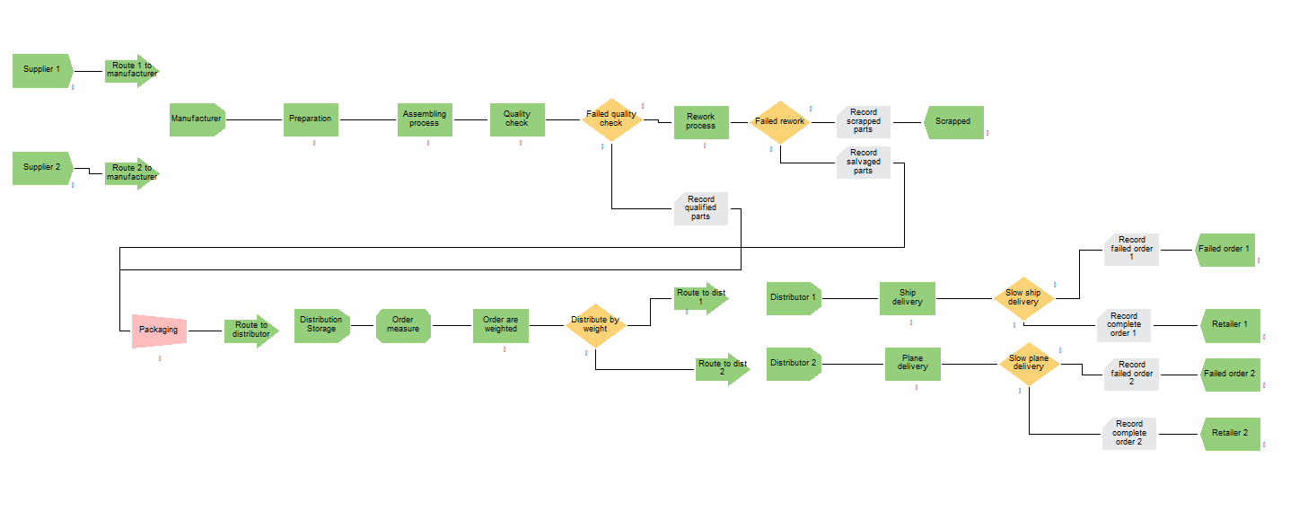

***Figure 2: Simulation model design phone mobile phone manufacturing***

Regarding the performance measures in manufacturing process, the first measure adopted in this paper will be *cost per unit* (CPU) which indicates the efficiency of the resource’s allocation in the entire supply chain (Duncan et al., 2001). Moreover, it is often used to enhance the revenue and profit of the supply chain (Duncan et al., 2001). In this report, this measurement will be calculated by accumulate the busy cost per hour of two main manufacturing resources namely labor and machinery, which are 9USD and 4USD per capacity per hour as collected above, and divide by the total units produced by the end of the manufacturing process. The second measure for manufacturing process in this model is *yield* which reflect the quality control management of the process. In interpretation, this indicator is used to measure the percentage of products produced without defection (Wu and Liao, 2012).

Considering the performance measure for distribution process, *distribution cost per unit* will firstly be examined to evaluate the distribution strategy applied in the supply chain. In this report, it will be calculated by summing up the average transportation cost by ship and by plane before dividing them to the total number of orders transported (Nwaogbe et al., 2013). Meanwhile, the *on time in full* indicator will be the second and the last measure in this report applied to examine the ratio of orders being distributed to the retailer on time with perfect quality to meet the market demand (Flora, 2022). This KPI will be measured by adding up the number of completed orders by both ship and plane then dividing the results by the total transported orders. These two KPI in combination could help manufacturing to examine and decide the distribution option for their products; for instance, whether it is better to deliver goods by ship, train or plane.

As could be observed in ***figure 3***crucial statistical data reflecting the proficiency of the model are gathered and summarised. The average waiting time for all of the manufacturing processes are lower than 1 hour in all three replications indicating the sensible time and resource capacity allocation for each process. Another significant outcome of the model is the total unit of phone produced which is the combination of salvaged phones after rework and the shipped phones that passed the quality check process. ***Figure 3*** illustrates that, following three replications, the average number of phones generated was 8349, a significantly higher number than the anticipated 6000 units shown in the data gathering section. This indicates that the model's smartphone manufacturing process is highly productive. Such optimistic data will make it simpler for the manufacturer to modify the production process to meet the performance indicators if needed.

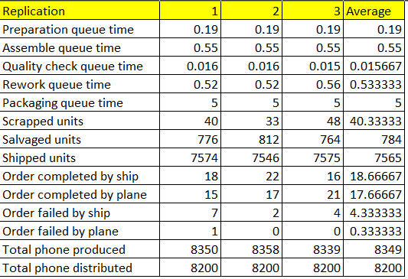

***Figure 3: Essential data generated from the simulation model***

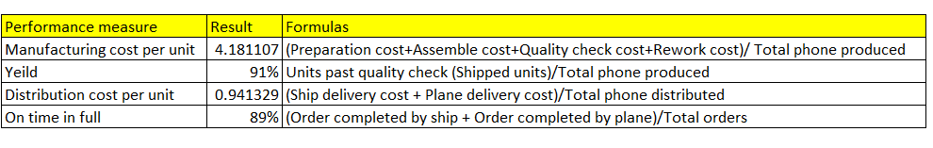

***Figure 4: Performance measure of manufacturing and distribution processes***

***Figure 4*** summarised the result and calculation of four proposed performance indicators. Firstly, some market research on smartphones is required in order to comprehend the implications of these findings. Miller (n.d.) claims that the majority of the expenses associated with the production of smartphone, which could cost up to $300 USD each, are related to raw materials. But when compared to the 317 USD average selling price of smartphones in recent years (Taylor, 2023), other expenses, such as those associated with production and distribution, also have a significant influence in determining the profitability of the smartphone industry. Thus, returning to the model, the manufacturing and distribution costs per unit are adopted as a key indicator to measure performance of the mobile phone supply chain. In interpretation, the manufacturing cost in the model is 4.18USD per unit which is acceptable. However, manufacturers using the simulation model developed for this study could still modify their production strategies to lower this cost without compromising their productivity because, as previously analysed, the model's overall productivity is considerably high. Reducing the capacity of resources, altering labour wages, and other changes are examples of these adjustments (Duncan et al., 2001). However, CPU alone could not fully assess the performance of the entire manufacturing process; thus, *yield* or *first time through* is applied in this research. The yield result in the model demonstrates that 91% of the smartphone past the quality check process after being assemble. When comparing to the number of units produced in the model after 30 days, the remaining 9% of defected goods is acceptable. However, if this model is applied to the practical scenario where the manufactured unit can reach up to 10 million per year, 9% of faulty products could be alarming.

Additionally, in the simulation model, using the *batch* module, phones are packaged with 200 per box before each box are weighted in the distribution station. At this point, boxes weighing more than fifty kilogrammes will be loaded onto ships for delivery at a cost of 0.5USD per kilogramme, while the remaining will be loaded onto planes for distribution at a cost of 3USD per kilogramme. As a result, the average *distribution cost per phones* is calculated to be 0.94USD. In this case, the decision makers could reduce this cost by changing the distribution method for their product. This decision could be supported by the second measurement in the distribution process which is *on time in full* which is 89% representing the number of qualified orders delivered on time to the retailers. When breaking down this result, it could be observed in ***figure 3*** that ship transportation account for more than 90% of failed orders. Thus, the policy maker could consider changing the method to distribute phone orders that are more than 50 killogrammes. For instance, the managers could either replace ship with train as another delivery resource or change the ship transportation partner.

In overall, although the established simulation model for smartphone manufacturers in this paper generates positive performance, its applicability is limited due to the following reasons. First off, there are many more performance measures that could be used in supply chain management (Duncan et al., 2001); as a result, the four measurements used in this research are not sufficient to capture every facet of a real-world supply chain. Second, as previously indicated, this model is a simplified version of a bigger one, thus some of the data had to be assumed, which made it impossible to guarantee that the results would be the same in a real-world setting. Thirdly, the data adopted to calculate the performance indicators in this study are likewise inadequate. To give an example, the *manufacturing cost per unit* estimated does not include the cost of raw materials or additional expenses like indirect labour cost. Therefore, in order to improve the model's applicability, it is recommended that future study in this field should enlarge the model scale, incorporate more performance measures, and avoid data assumption.

# **References:**

Asih, H. M., Eng, C. K., & Ph'ng, L. M. (2019). Simulation of mixed-load testing process in an electronic manufacturing company. *Telkomnika, 17*(1), 408-416. <https://doi.org/10.12928/telkomnika.v17i1.10146>

Ben Rabia, M. A., & Bellabdaoui, A. (2022). Simulation-based analytics: A systematic literature review. *Simulation Modelling Practice and Theory, 117*, 102511. <https://doi.org/10.1016/j.simpat.2022.102511>

Brown, R. (2022). *The Cost of Making an iPhone*. Investopedia. <https://www.investopedia.com/financial-edge/0912/the-cost-of-making-an-iphone.aspx>

DFH global logistics. (n.d.). *Air Freight vs. Sea Freight: Costs, Shipping time, and Carbon Footprint*. <https://deefreight.com/air-freight-vs-sea-freight/>

Duncan, T. E., Pasik-Duncan, B., & Stettner, Ł. (2001). Average cost per unit time control of stochastic manufacturing systems: Revisited. *Mathematical Methods of Operations Research (Heidelberg, Germany), 54*(2), 259-278. <https://doi.org/10.1007/s001860100146>

Flora, M. (2022). *What Is On Time & In Full (OTIF) And How To Measure It*. ShipBob. <https://www.shipbob.com/blog/otif/#:~:text=OTIF%20or%20On-Time%20In-Full%20is%20a%20KPI%20used,can%20also%20be%20applied%20throughout%20the%20supply%20chain>.

Lin, Y., Hsieh, T., Yang, C., Shen, V. R. L., Juang, T. T., & Huang, T. (2020). Review on petri net modeling and analysis of a smartphone manufacturing system. *Cogent Engineering, 7*(1), 1851630. <https://doi.org/10.1080/23311916.2020.1851630>

Makinde, O., Selepe, R., Munyai, T., Ramdass, K., & Nesamvuni, A. (2022). Improving the supply chain performance of an electronic product-manufacturing organisation using DMAIC approach. *Cogent Engineering, 9*(1)<https://doi.org/10.1080/23311916.2021.2025196>

Miller, J. (n.d.). *How Much Does It Cost To Make a Smartphone? (A Comprehensive Breakdown)*. Hello Smartlife. <https://hellosmartlife.com/how-much-does-it-cost-to-make-a-smartphone/?utm_content=cmp-true>

Mustafee, N., Katsaliaki, K., & Taylor, S. J. E. (2021). Distributed approaches to supply chain simulation: A review. *ACM Transactions on Modeling and Computer Simulation, 31*(4), 1-31. <https://doi.org/10.1145/3466170>

Nwaogbe, O. R., Omoke, V., Ubani, E. C., & Ukaegbu, S. I. (2013). Cost minimisation of product transhipment for physical distribution management. *Journal of Transport and Supply Chain Management, 7*(1), e1-e9. <https://doi.org/10.4102/jtscm.v7i1.94>

Pallet2Ship. (n.d.). *Sea Freight vs Air Freight - What you need to know*.<https://www.pallet2ship.co.uk/sea-freight-vs-air-freight/#:~:text=Generally%2C%20sea%20freight%20can%20be,the%20cost%20of%20sea%20freight>

Russkikh, P. A., & Kapulin, D. V. (2020). Simulation modeling for optimal production planning using tecnomatix software. *Journal of Physics. Conference Series, 1661*(1), 12188. <https://doi.org/10.1088/1742-6596/1661/1/012188>

Tamás, P., Tollár, S., Illés, B., Bányai, T., Tóth, Á. B., & Skapinyecz, R. (2020). Decision support simulation method for process improvement of electronic product testing systems. *Sustainability (Basel, Switzerland), 12*(7), 3063. <https://doi.org/10.3390/su12073063>

Taylor, P. (2023). *Average selling price of smartphones worldwide 2016-2021*. Statista. <https://www.statista.com/statistics/788557/global-average-selling-price-smartphones/#:~:text=The%20average%20selling%20price%20%28ASP%29%20of%20smartphones%20is,dollars%20more%20expensive%20than%20the%20ASP%20in%202016>.

Vlasov, A. I., & Gonoshilov, D. S. (2019). Simulation of manufacturing systems using BPMN visual tools. *Journal of Physics. Conference Series, 1353*(1), 12043. <https://doi.org/10.1088/1742-6596/1353/1/012043>

Wang, Y., & Fang, L. (2008). Development of an intelligent agent-based mobile phone supply chain simulation system. Paper presented at the 3508-3513. <https://doi.org/10.1109/ICSMC.2008.4811841>

Wu, C., & Liao, M. (2012). Generalized inference for measuring process yield with the contamination of measurement errors-quality control for silicon wafer manufacturing processes in the semiconductor industry. *IEEE Transactions on Semiconductor Manufacturing, 25*(2), 272-283. <https://doi.org/10.1109/TSM.2011.2181433>

Wu, C., Shi, Y., Arthanari, T., Gao, Y., & Li, X. (2023). Examining the chinese mobile phone industry in the reverse supply chains. *Computers & Industrial Engineering, 182*, 109407. <https://doi.org/10.1016/j.cie.2023.109407>

Yassine, A., Khalid, B., & Said, E. (2019). Supply chain modeling and simulation using SIMAN ARENA a case study*. International Journal of Advanced Computer Science & Applications, 10*(3)<https://doi.org/10.14569/IJACSA.2019.0100329>

Zhao, R., Zou, G., Su, Q., Zou, S., Deng, W., Yu, A., & Zhang, H. (2022). Digital twins-based production line design and simulation optimization of large-scale mobile phone assembly workshop. *Machines (Basel), 10(*5), 367. <https://doi.org/10.3390/machines10050367>